Operator and assignments
- Increment and decrement operator
- Arithmetic operators
- String concatenation operator
- Relational operators
- Equality operator
- Instanceof operator
- Bitwise operators
- Short circuit operators
- Type cast operator
- Assignment operator
- Conditional operator
- new operator
- [] operator
- Java operator precedence
- Evaluation order of java operands
Increment and decrement operator:
Diagram 1:
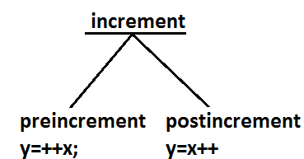
Diagram 2:
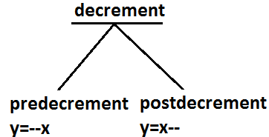
Example:
Expression | Initial value of x | Final value of x | Final value of y
Y=++x; | 10 | 11 | 11
Y=x++; | 10 | 11 | 10
Y=--x; | 10 | 9 | 9
Y=x--; | 10 | 9 | 10
- We can apply increment or decrement operator only for variables but not for constant values.
Example:
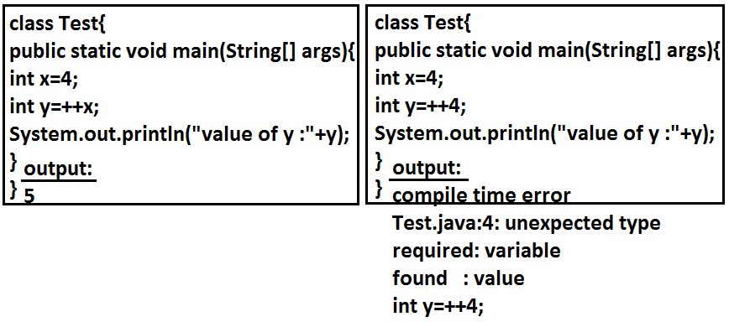
- Nesting of increment or decrement operators is not allowed.
Example:
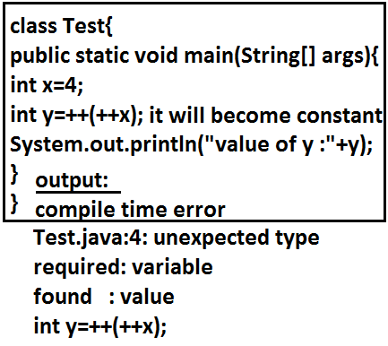
- We can’t apply increment or decrement operator for final variables.
Example:
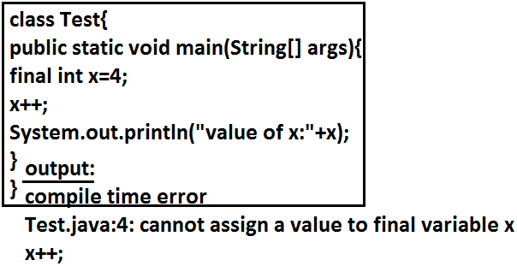
- We can apply increment or decrement operator for any primitive type except Boolean.
Example:
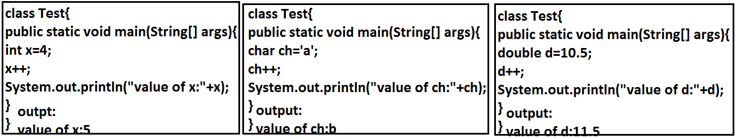
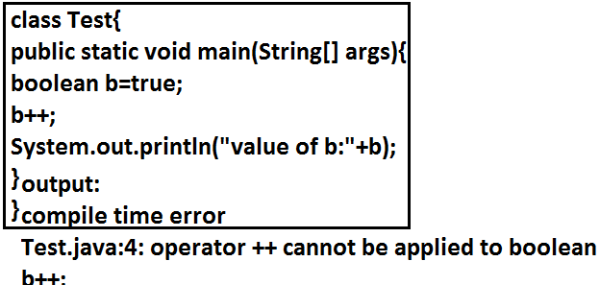
- If we apply any arithmetic operator between two variables “a” and “b” the result type is always.
max(int,typeof a,typeof b)
Example 1:
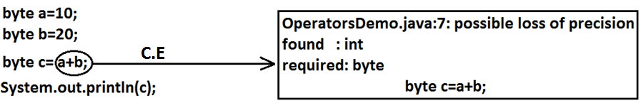
Example 2:
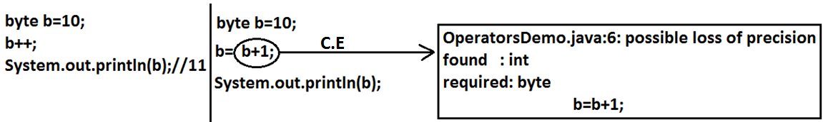
- In the case of increment or decrement operator the required type-casting will be performed automatically by the compiler.
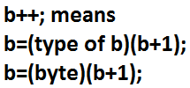
Example:
byte b=10;
b++;
System.out.println(b);//11
Arithmetic operators: (+,-,*, /, %)
- If we apply any arithmetic operation between two variables “a” and “b”. The result type is always.
max(int, type of a, type b)
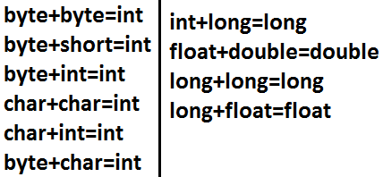
Example:
System.out.println('a'+1);//98
System.out.println('a'+'b');//195
System.out.println(10+0.5);//10.5
System.out.println('a'+3.5);//100.5
Infinity:
- In the case of integral arithmetic (byte, short, int, long) there is no way to represent infinity.
- Hence if infinity is the result then we will get ArithmeticException.
Example:
- But in floating point arithmetic(float, double), there is a way to represent infinity. For this Float and Double classes contains the following two constants.
POSITIVE-INFINITIVE;
NEGITIVE-INFINITIVE;
- Hence if infinity is the result we won’t get any runtime exception in floating point arithmetic.
Example:
System.out.println(10/0.0);//+Infinity
System.out.println(-10/0.0);//-Infinity
NaN(Not a Number):
- In the case of integral arithmetic there is no way to represent “undefined results”. Hence if the result is undefined we will get runtime exception saying ArithmeticException.
Example:
- But in floating point arithmetic (float, double), there is a way to represent undefined result for this Float and Double classes contain “NaN”.
- Hence if the result is undefined, we won’t get any runtime exception in floating point arithmetic.
Example:
System.out.println(0.0/0);//NaN
System.out.println(-0.0/0);//NaN
System.out.println(0/0.0);//NaN
- For any x value including NaN the following expressions return false.
Example:
class Test
{
public static void main(String[] args)
{
int x=10;
System.out.println(x>Float.NaN);//false
System.out.println(x<Float.NaN);//false
System.out.println(x>=Float.NaN);//false
System.out.println(x<=Float.NaN);//false
System.out.println(x==Float.NaN);//false
}
}
- For any x value including NaN the following expression return true.
Example:
class Test
{
public static void main(String[] args)
{
int x=10;
System.out.println(x!=Float.NaN);//true
System.out.println(Float.NaN!=Float.NaN);//true
}
}
Summary:
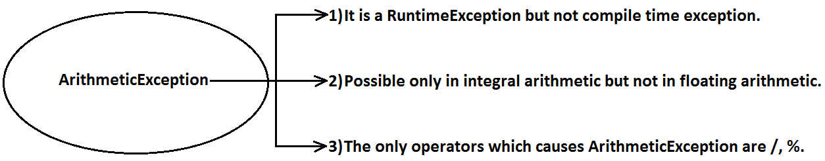
String concatenation operator:
- The only operator which is overloaded in java is “+” operator. Sometime it acts as arithmetic addition operator and some time concatenation operator.
- If at least one argument is string type then “+” operator acts as concatenation and if both arguments are number type then it acts as arithmetic addition operator.
Example 1:
String a="bhaskar";
int b=10,c=20,d=30;
System.out.println(a+b+c+d);//bhaskar102030
System.out.println(b+c+d+a);//60bhaskar
System.out.println(b+c+a+d);//30bhaskar30
System.out.println(b+a+c+d);//10bhaskar2030
Example 2:
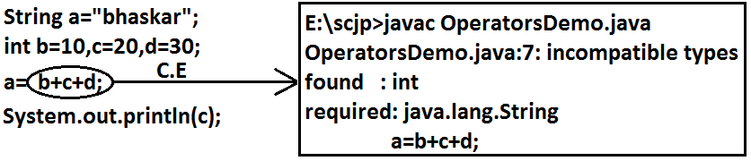
Example 3:
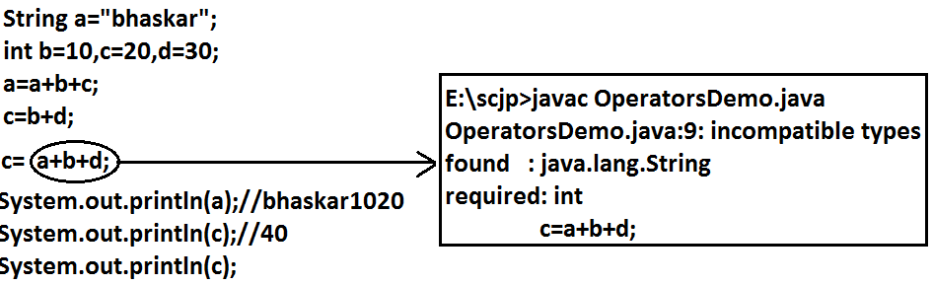
Relational operator: (<, <=, >, >=)
- We can apply relational operators for every primitive type except boolean.
Example:

- We can’t apply relational operators for the object types.
Example:
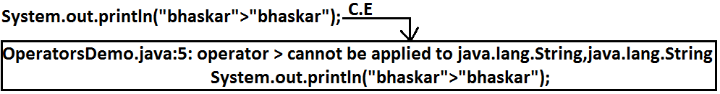
- We can’t perform nesting of relational operators.
Example:
Equality operator :(==,!=)
- We can apply equality operators for every primitive type including boolean type also.
Example:
System.out.println(10==10.0);//true
System.out.println('a'==97.0);//true
System.out.println(true==true);//true
System.out.println('a'!='b');//true
- We can apply equality operator even for object reference also.
- In the case of object references == (double equal operator) is always meant for reference comparison only (address comparison).
- i.e. r1==r2 return true if and only if both r1 and r2 point to the same object.
Example:
Thread t1=new Thread();
Thread t2=new Thread();
Thread t3=t1;
System.out.println(t1==t2);//false
System.out.println(t1==t3);//true
Diagram:
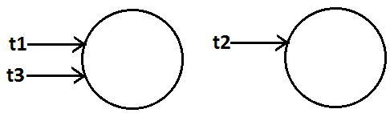
- To use equality operator compulsory there should be some relationship between argument type(either parent-child (or)child-parent (or) same type)otherwise we will get compile time error saying ” incomparable types”.
Example:
Object o=new Object();
String s=new String("bhaskar");
StringBuffer sb=new StringBuffer();
System.out.println(o==s);//false
System.out.println(o==sb);//false
Diagram:

- For any object reference of, r==null is always false. But null==null is true.
== Vs .equals():
- ==operator is always meant for reference comparison whereas .equals() method mostly meant for content comparison.
Example:
String s1=new String("bhaskar");
String s2=new String("bhaskar");
System.out.println(s1==s2);//false
System.out.println(s1.equals(s2));//true
Diagram:
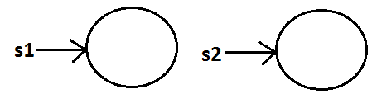

Instanceof operator:
- We can use this operator to check whether the given object is of particular type (or) not.
Syntax:
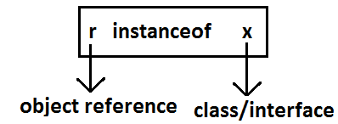
Example:
Thread t=new Thread();
System.out.println(t instanceof Thread);//true
System.out.println(t instanceof Object);//true
System.out.println(t instanceof Runnable);//true
Diagram:
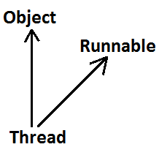
Note:
- To use “instanceof” operator compulsory there should be some relationship between argument types (either parent-child (or) child-parent (or) same type) otherwise we will get compile time error saying “inconvertible types”.
Example:
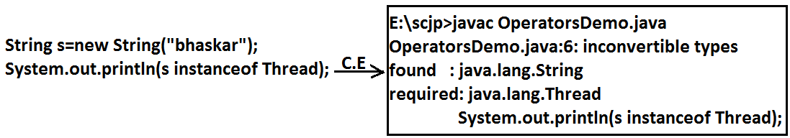
- Whenever we are comparing parent object is child type or not by using instanceof operator then we will get “false” as output.
Example:
Object o=new Object();
System.out.println(o instanceof String);//false
- For any class or interface x
null instanceof x the result is always “false”.
Example:
System.out.println(null instanceof String);//false
Bitwise operators:
& (AND): If both arguments are true then result is true.
| (OR): if at least one argument is true. Then the result is true.
^ (X-OR): if both are different arguments. Then the result is true.
Example:
System.out.println(true&false);//false
System.out.println(true|false);//true
System.out.println(true^false);//true
- We can apply bitwise operators even for integral types also.
Example:

Bitwise complement (~) (tilde symbol) operator:
- We can apply this operator only for integral types but not for boolean types.
Example 1:

Example 2:
System.out.println(~4);//5
Diagram:
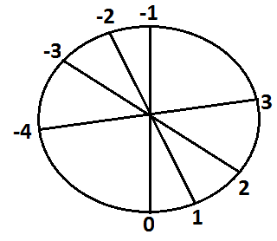
Boolean complement (!) operator:
- This operator is applicable only for boolean types but not for integral types.
Example:

System.out.println(!true);//false
System.out.println(!false);//true
Summary:
&
| Applicable for both boolean and integral types.
^
~-------- Applicable for integral types only.
! --------Applicable for boolean types only.
Short circuit (&&, ||) operators:
- These operators are exactly same as normal bitwise operators &, | except the following differences.
&,| | &&,||
- Both arguments should be evaluated always. | - Second argument evaluation is optional.
- Relatively performance is low. | - Relatively performance is high.
- Applicable for both integral and boolean types. | - Applicable only for boolean types but not for integral types.
- r1&&r2
- r2 will be evaluated if and only if r1 is true.
- r1||r2
- r2 will be evaluated if and only if r1 is false.
Example 1:
class OperatorsDemo
{
public static void main(String[] args)
{
int x=10, y=15;
if(++x>10(operator)++y<15)
{
++x;
}
else
{
++y;
}
System.out.println(x+"------------"+y);
}
}
Output:
operator | x | y
& | 11 | 17
| | 12 | 16
&& | 11 | 17
|| | 12 | 15
Example 2:
class OperatorsDemo
{
public static void main(String[] args)
{
int x=10;
if(++x<10(operator)x/0>10)
{
System.out.println("hello");
}
else
{
System.out.println("hi");
}
}
}
&& | Output: Hi
& | Output: R.E: Exception in thread "main" java.lang.ArithmeticException: / by zero
Type-cast operator (primitive type casting):
- There are two types of primitive type casting.
- Implicit type casting.
- Explicit type casting.
Implicit type casting:
- Compiler is the responsible for this typecasting.
- Whenever we are assigning smaller data type value to the bigger data type variable this type casting will be performed.
- Also known as widening or up casting.
- There is no lose of information in this type casting.
- The following are various possible implicit type casting.
Diagram:

Example 1:
int x='a';
System.out.println(x);//97
Note: Compiler converts char to int type automatically by implicit type casting.
Example 2:
double d=10;
System.out.println(d);//10.0
Note: Compiler converts int to double type automatically by implicit type casting.
Explicit type casting:
- Programmer is responsible for this type casting.
- Whenever we are assigning bigger data type value to the smaller data type variable then explicit type casting is required.
- Also known as Narrowing or down casting.
- There may be a chance of lose of information in this type casting.
- The following are various possible conversions where explicit type casting is required.
Diagram:
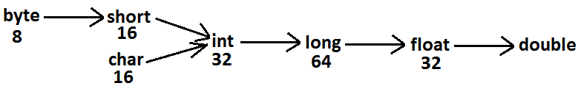
Example 1:
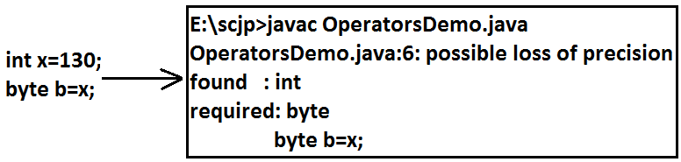
Example 2:
int x=130;
byte b=(byte)x;
System.out.println(b);//-126
Analysis:
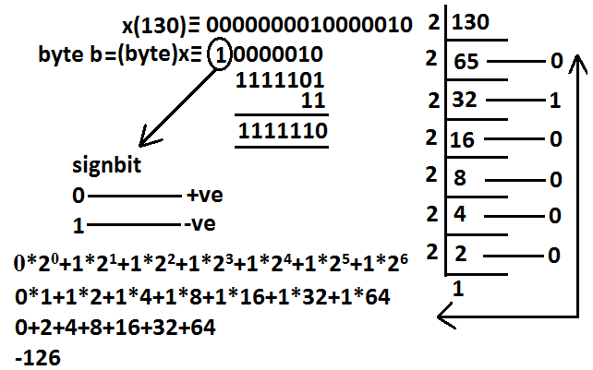
- Whenever we are assigning bigger data type value to the smaller data type variable by explicit type casting the most significant bit(MSB)will be lost.
Example:
int x=150;
short s=(short)x;
System.out.println(s);//150
byte b=(byte)x;
System.out.println(b);//-106
- Whenever we are assigning floating point data types to the integer data type by explicit type casting the digits after the decimal point will be loosed.
Example:
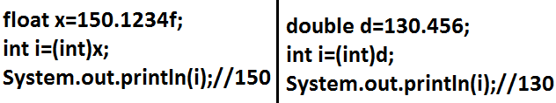
Assignment operators:
- They are three types of assignment operators.
Simple assignment:
Example: int x=10;
Chained assignment:
Example:
int a,b,c,d;
a=b=c=d=20;
System.out.println(a+"---"+b+"---"+c+"---"+d);//20---20---20---20
- We can’t perform chained assignment directly at the time of declaration.
Example 1:
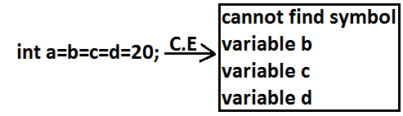
Example 2:
int a,b,c,d;
a=b=c=d=30;
Compound assignment:
- Sometimes we can mix assignment operator with some other operator to form compound assignment operator.
- The following is the list of all possible compound assignment operators in java.
Example 1:
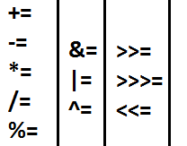
- In the case of compound assignment operator the required type casting will be performed automatically by the compiler similar to increment and decrement operators.
Example 2:
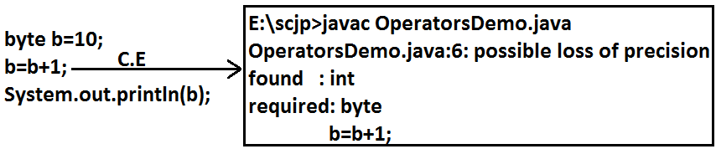

Example 3:
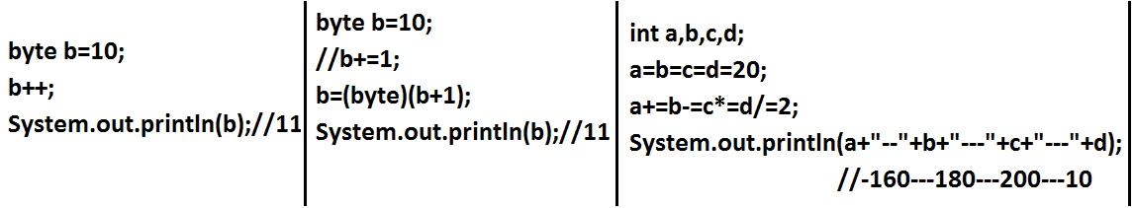
Conditional operator:
- The only ternary operator which is available in java is conditional operator.
Example 1:
int x=(10>20)?30:40;
System.out.println(x);//40
- We can perform nesting of conditional operator also.
Example 2:
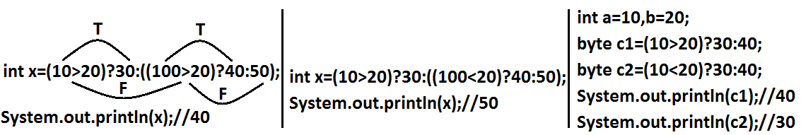
Example 5:
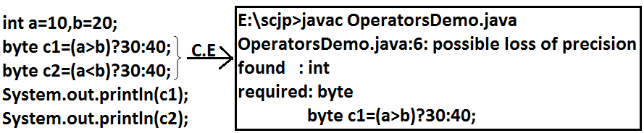
Example 6:
final int a=10,b=20;
byte c1=(a>b)?30:40;
byte c2=(a<b)?30:40;
System.out.println(c1);//40
System.out.println(c2);//30
new operator:
- We can use “new” operator to create an object.
- There is no “delete” operator in java because destruction of objects is the responsibility of garbage collector.
[] operator:
- We can use this operator to declare and construct arrays.
Java operator precedence:
Unary operators:
[], x++, X--,
++x,--x, ~,!,
new, <type>.
Arithmetic operators:
*,/,%,
+,-.
Shift operators:
>>,>>>,<<.
Compression operators:
<, <=,>,>=, instanceof.
Equality operators:
==,!=
Bitwise operators:
&,^,|.
Short circuit operators:
&&,||.
Conditional operator:
(?:)
Assignment operators:
+=,-=,*=,/=,%=.
Evaluation order of java operands:
- There is no precedence for operands before applying any operator all operands will be evaluated from left to right.
Example:
class OperatorsDemo
{
public static void main(String[] args)
{
System.out.println(m1(1)+m1(2)*m1(3)/m1(4)*m1(5)+m1(6));
}
public static int m1(int i)
{
System.out.println(i);
return i;
}
}
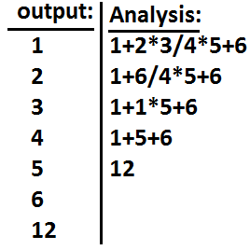
Example 1:
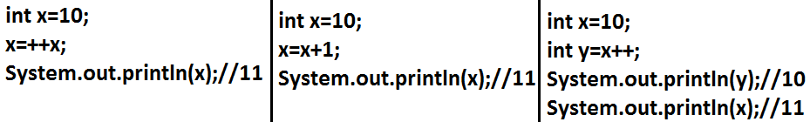
Example 2:
int i=1;
i+=++i + i++ + ++i + i++;
System.out.println(i);//13Analysis:
i=i+ ++i + i++ + ++i + i++;
i=1+2+2+4+4;
i=13;

